MOTIVATION FOR SYSTEM IMPLEMENTATION

In Malawi, hospitals are always congested almost on a daily basis and by the end of the day many people return to their homes without receiving the recommended treatment, a doctor’s appointment system would help solve this problem.
The implementation of this system in hospitals, especially community hospitals will be beneficial to the patients as well as the workers at the hospital. The workers will be able to know how many patients they are handling for the day exclusive emergencies. This will help them be organized and prepare beforehand the proper way to treat the patient since through the booking system the patient provides their symptoms.
In terms of the patients, they will have assurance of getting treatment since they have booked a specified time slot just for them to be treated.
Although, the system if implemented may not be easily accepted due to the illiteracy level in some communities. Still more, through practice and using our vernacular language when the system is interacting with patients would help overcome this barrier.
Finally, the implementation of this system has come due to congestions in hospitals which may lead to patients leaving hospitals without being treated. This system would help patients have specified timeslots just for their treatments hence only patients assigned timeslots for the day will be available at the hospitals thereby preventing congestion.

OOP DESIGN USING UML DIAGRAMS
In the system, there are four class notations. The hospital class notation is connected to the personnel class. the personnel class is the parent class to the doctor and patient class hence inheritance association.

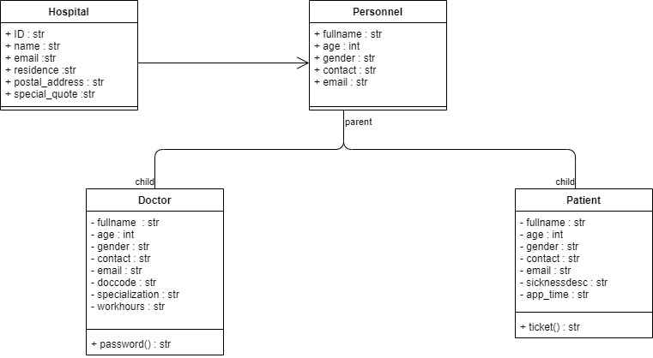

DATABASE DESIGN OF THE SYSTEM
The database name is doctor_appointment . there are three tables available namely: - Hospital, Doctor and Patient

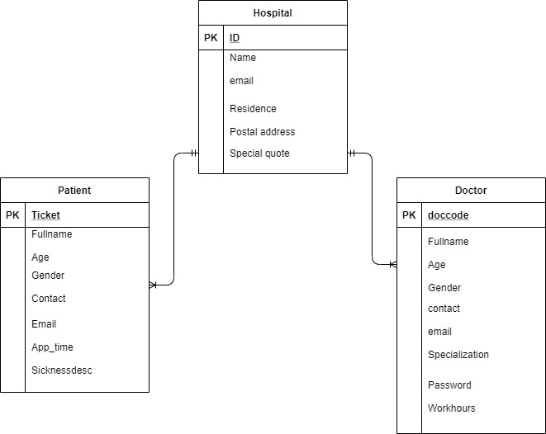

RELEVANT INFORMATION:
This system is built for a single hospital. This means that only a single hospital can use the system. Not more than one hospital institution can work on the system.

